**REDESINING TPMS AND BCM FOR ZONAL ARCHITECTURE**

Dr. Shubashish Tiwari Associate Professor Shaik Rahil Sharookh N Muradi

Electronics and communication Engineering Electronics and communication Engineering Electronics and communication Engineering

Gitam University Gitam University Gitam University

Bangaluru, India Bangaluru, India Bangaluru, India

***Abstract--- The Tire pressure Monitoring system is proposed to monitor the changes in the tire pressure and temperature using Splunk Enterprise. The proposed system is implemented using the Raspberry Pi interfaced with 5 inch HDMI Touch Display, SPD100g Pressure Sensor and DS18B20 Temperature Sensor. The system senses the high and low pressure, temperature of the tire and displays the information on the display. The log of the Tire Pressure Monitoring system is indexed with Splunk Enterprise. Splunk Enterprise is a platform for searching, analyzing and visualizing the machine generated data from the applications, sensors and devices. It communicates with the different log files and stores the file data in the form of events into local indexes. By using Splunk Enterprise Pivots, Dashboards and Reports can be created.***

***Keywords--- TPMS, HDMI Display,SPD100g Sensor, DS18B20 Sensor, Pivots, Dashboards, Reports.***

# INTRODUCTION

Tire pressure plays an important role in the safety and fuel consumption considerations of automobiles and designed to monitor the air pressure inside the pneumatic tires on vehicles. Vehicles moving with low or high tire pressure will consume more fuel. Leakage of air from tire is not detected means can cause serious problems during running of vehicle. Therefore, the real-time monitoring of automobile tire pressure has an important consideration. There are two types of TPMS monitoring schemes, one is the indirect method and the other is direct method. The indirect method is based on the wheel speed signal such as TPMS with Circumference method and TPMS with Frequency method. The Direct method is based on the pressure sensor such as TPMS with Pressure sensor. The disadvantage of the indirect method is that the data is not accurate, high fault rate, and its maintenance is complex whereas in the direct method it is highly accurate and quick detection. So the Direct method is implemented in the proposed system.

Tire Pressure Information is given to the driver in real- time via Gauge, Pictogram display and the Warning or Indicator light. The proposed system uses Gauges and Indicator light to indicate the tire pressure and temperature. As the safety parameters of a tire are directly related to its pressure and temperature, TPMS systems have the function of measuring the tire pressure and correcting it according to the instantaneous temperature of the tire. Almost all TPMS systems measuring these two physical values (pressure and temperature) with special sensors use electronic devices located in small modules placed next to the valve and positioned on the outer part of the rim, in other words, inside the tire.

TPMS logs is indexed with the Splunk Enterprise tool in this proposed system. It is a log parser tool where it can parse the huge logs and makes additional analysis on the logs. Splunk is the ultimate solution for log processing and best solution for exploring logs.

The proposed work is based on an embedded system consisting of Raspberry Pi 3 as a low-cost ARM powered Linux based computer. The ARM Cortex 64 bit embedded platform in the Raspberry Pi 3 supports floating point operations thus improving the real time performance of the system.

Section 2 describes the related works, Section 3 describes the methods and models, Section 4 describes the results and discussions, and Section 5 gives the conclusion of the work presented in this paper.

# LITERATURE SURVEY

In a method is designed to monitor tire pressure of any type of vehicles with the help of wireless network and wireless charging/remote charging. The pressure sensor senses low or high are pressure inside the tire and informs to the kit and then sound alarm is generated. The transmission of signal is done through wireless communication which can be Bluetooth or Wi-Fi and to charge tire pressure kit battery, wireless charging methodology is used.

In the fuzzy logic algorithm is proposed for the method of auto-learning sensor ID’s. The Classic Algorithm approaches have been used for auto-learning of sensor IDs. The proposed fuzzy logic controller is assigned with the two input variables such as Driving time and the Reception State. The inputs to the fuzzy controller are driving time, acceleration data, number of rotating messages received and vehicle speed and the only output variable is the sensor state.

In proposes the conventional tire location registration algorithms which uses the Inter Frame Spacing Pattern to identify the location of each tire by the Global Identifier. This system uses pressure and acceleration Sensors. Each sensor with different Inter Frame Spacing Pattern can send a frame during after obtaining the authority to access the channel. This system is based on the Slotted ALOHA for the analysis of the probability of the packet Collision.

In the author has dealt with the software implementation for an indirect Tire Pressure Measurement

System based on the Anti-lock Braking System present in a car.

The software simulation model uses the real-time controller and a Simulink model. This model is able to find the tire dimensions, vehicle speed and steering wheel angle, track, wheelbase and is able to command each wheel rotational speed according to the acquired data. An Android application is also implemented for the purpose of helping the driver to determine and solve the problem of tire under inflation.

In [5], employs advanced integration techniques to provide a TPMS solution that provides real-time tire pressure monitoring at both stationary and movement condition of the vehicle and alerts the driver about improperly inflated tires. The unit includes apressure sensor, microcontroller, RF transmitter and long life battery. The TPMS unit communicates by an on- board RF receiver and displays real-time tire pressure of all tires.

In [6], a method is designed for hollow axle based wheel set up to monitor the tire pressure. The electronics package of this system could be easily integrated with any of the automobile configuration. The wireless transmission is done throughBluetooth modules, which could be done by Zigbee modules. This system is devised for one tire assembly which could be expanded to four tire automobile systems. Solenoid valves are used to make inflation and deflation simpler. The system is also expanded to incorporate many predefined tire pressure settings allowing the user to select them and also to manually enter the desired pressure settings.

In [7], deals with the automobile Tire Pressure monitoring system by adopting the Infineon company's SP37 chips which is used for collecting and sending data of automobile tire's Pressure in time and then adopting MAX1473 chip wireless to receive, relying on the MSP430 chip's which deals with data from the tire Pressure, also and warning to drivers so as to avoid accident.

In [8], proposes the automated tire pressure monitoring and regulating system. This system is implemented in a tire with real time variables.The pressure in the valve stem in the tire is measured with the help of a pressure sensor. The value is digitized and the microcontroller transfers the digitized value through the zigbee network.

In [9], deals with the frequency analysis based tire pressure monitoring. The aim of this system is to analyzethat how the efficiency of the frequency analysing is increased based tire-pressure monitoring systems with the application of distinct signal processing methods.In this system Fast Fourier Transform (FFT) based methods are used to estimate the Eigen frequency of wheels.

In [10], the method of tire pressure monitoring using wireless communication was proposed.The proposed TPMS has an electronic unit that directly screws onto the stem of tire. The unit includes a pressure sensor and switch, signal conditioning unit, microcontroller, RF transmitter and a battery. An OnboardRF receiver communicates with the TPMS unit and displays real-time tire pressure of all tires. The system and each TPMS unit have unique ID code to prevent false data reception fromneighbouring vehicles. The warning is generated whenever tire pressure crosses the maximum or minimum safe pressure level, or when it changes abruptly. This lower level and upper limit of tire

pressure or safe range of abrupt change can be modified by user through the user interface.

In the proposed work, tire pressure is monitored using the pressure sensor and temperature sensor and the logs are processed with the Splunk Enterprise using the Machine learning algorithm.

# HARDWARE DESCRIPTION

The proposed Embedded system consists of Raspberry Pi 3 board with ARM Cortex Processor for the real time tire pressure monitoring using Splunk Enterprise. 5 inch HDMI Display, SPD100G pressure sensor and DS18B20 temperature sensor are used to monitor the tire pressure and temperature in automobiles.

*Block Diagram*

The block diagram of the proposed system for Real time tire pressure monitoring is shown in the Figure 1.5 inch HDMI Display is interfaced with the Raspberry Pi to display the results and it indicates the various pressure and temperature of the tire. The Splunk Enterprise uses the Machine learning algorithm for the log management process. By using the Machine learning process in Splunk Enterprise Pivots, Dashboards and Reports are created is shown in the Figure 2.

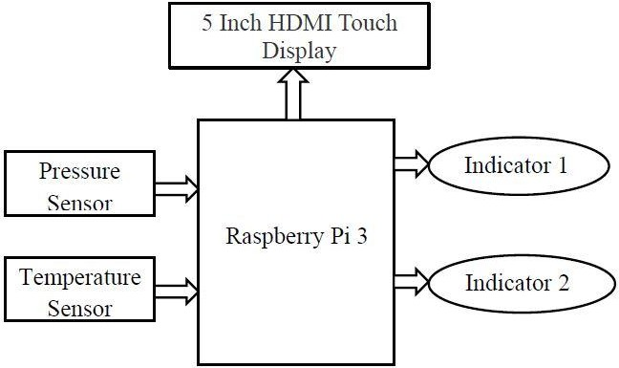

## Fig.1: Block Diagram of the Proposed System

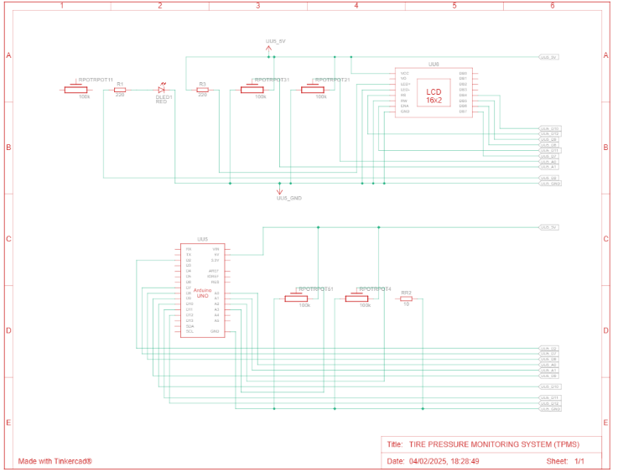

*HDMI Display*

Figure 3 shows the HDMI display interface with Raspberry Pi.It supports standard HDMI interface input, can be directly inserted with Raspberry Piwhich has 800 × 480 resolution and with resistive touch screen, it also supports touch control.

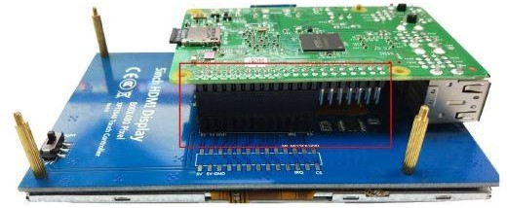

**Fig.3: HDMI Display interfaced with Raspberry pi**

*SPD100G Pressure Sensor*

The Smart Pressure Device SPD series of pressure sensors comes in two distinct types such as Gauge and Absolute. It is based on Bridge resistance which gives very accurate interface to a digital environment. It measures the pressure in the unit of Kilo Pascal (kPa).It can measure upto 0-650 kPa pressure range.

*DS18B20 Temperature Sensor*

The DS18B20 digital thermometer provides 9-bit to 12- bit Celsius temperature measurements. It measures the pressure in the unit of Celsius ( ˚C).

# SOFTWARE DESCRIPTION

The proposed system uses Splunk Enterprise which uses Machine learning algorithm such as Regression and Classification algorithms which is used to Collect, Deploy, Evaluate, Transform and Visualize the data logs of the tire pressure monitoring system.

The Splunk Enterprise is used to collect, manage and analyze variety of data. It can gain real time insight from sensors, devices and operational technologies. The main functionalities is to Search and investigate a particular outcome, Create dashboards to visualize and analyze the data logs and stores the data for later use. The benefits are real time processing, input can be in any format such as CSV (Comma Separated Values), JSON (Javascript Object Notation) and others and helps in predicting the resources accurately needed for scaling up the infrastructure.

the components in the Splunk Enterprise. The three main components are Splunk Forwarder, Splunk Indexer and Search Head. The forwarder is used for data forwarding,indexer is used for parsing and indexing the data. The search head is used for searching, analyzing and reporting.

The visualization helps to communicate complex ideas and data patterns with clarity and precision. Splunk provides different ways to build reports and dashboards to visualize the search results coming from the data indexed into it. One of the most important benefits of visualization is that it allows access to huge amounts of data. The Splunk provides different chart types to visualize the data.

*Dashboards*

Dashboards includes searches, visualizations and input controls that captures and present the available data. Dashboards are popular for measuring and tracking the performance and they represent a useful way to manage specific metrics. Splunk provides several ways of creating meaningful dashboards that are built from the searches and visual charts. The end result of using for monitoring is usually a dashboard with several visualizations. A dashboard is made up of report panels, which can be chart, gauge, table or list of search results.

*Reports*

Reports are based on single searches and can include visualizations. The report can be opened as pivot or search to refine the parameters and to explore the data. By using the edit option in report it is able to edit the description, permission and schedule. The various options in report are Clone, Embed and Delete. The various types of reports are Values over time, Top values and Rare values.

*Machine Learning Algorithm*

The Decision Tree algorithm is a Machine learning Algorithm used in Splunk Enterprise for search and predicting the indexed data’s. It is used to predict outcomes based on predictor variables. Decision trees are used for both Classification and Regression trees. Decision tree estimator is to fit a model to predict the value of a categorical field.

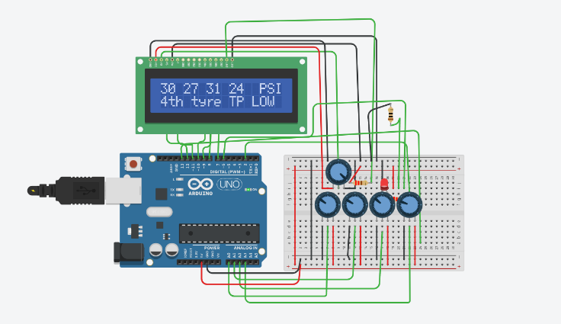

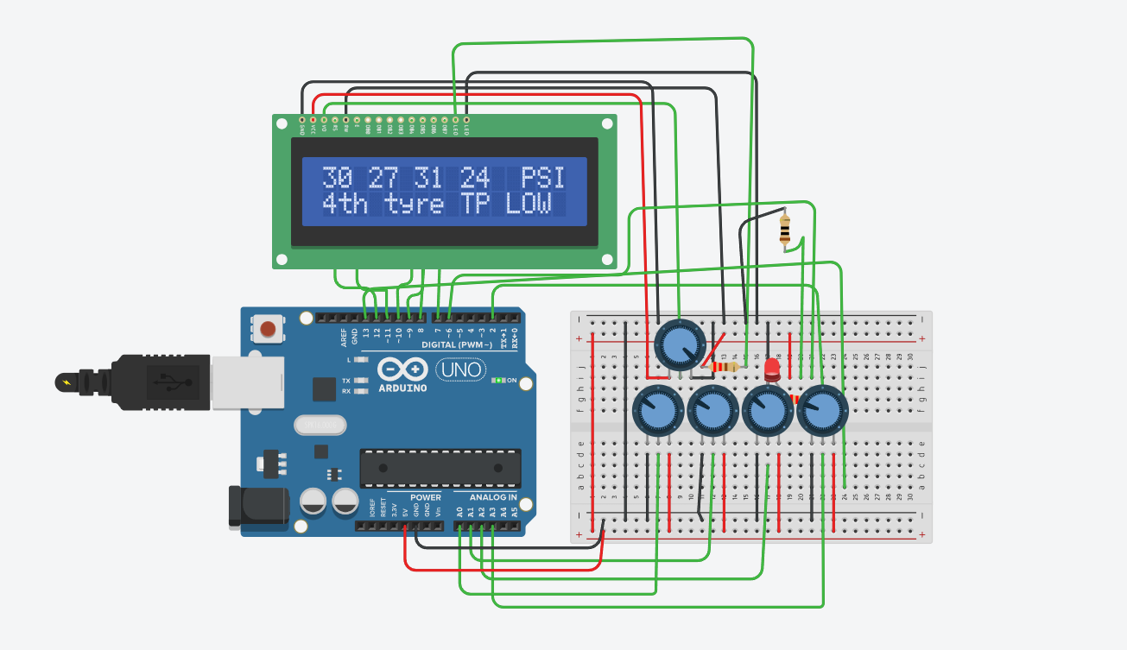

Classification trees are designed for dependent variables that take a finite number with prediction error measured in terms of misclassification cost.

Regression trees are for dependent variables that take continuous or ordered discrete values, with prediction error typically measured by the squared difference between the observed and predicted values.

# EXPERIMENTAL RESULTS

Around 10log datasets of pressure and temperature of tire pressure monitoring have been processed in the proposed work. The TPMS logs are processed using Splunk

Enterprise and visualizing pivots, dashboards, reports are created.

*Experimental Setup*

Figure 5 shows the experimental setup of the Tire pressure monitoring system. The experimental setup consists Raspberry pi, 5 inch HDMI display, SPD100G pressure sensor and DS18B20 temperature sensor.

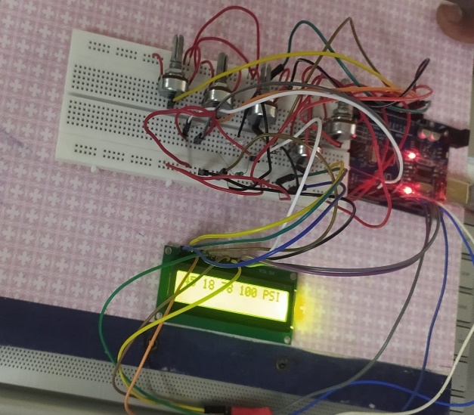

## Fig.5: Experimental Setup

*Hardware Results*

Figure 6 and 7 shows the tire pressure and temperature information displayed in gauge. The temperature is displayed in the unit of Celsius and pressure is displayed in the unit of Kilopascal.

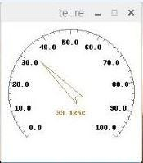

## Fig.6: Temperature Gauge

The Tire pressure and temperature logs are tabulated. The log data is a definitive record of every resource when it comes to troubleshooting and supporting the process. Table 1 shows the different pressure and temperature logs.

## Table 1:TPMS Logs

|  |  |  |
| --- | --- | --- |
| **Logs** | **Pressure**  **(kPa)** | **Temperature**  **(˚C)** |
| Log 1 | 175 | 33.125 |
| Log 2 | 99 | 29.896 |
| Log 3 | 193.053 | 36.321 |
| Log 4 | 186.158 | 34.964 |
| Log 5 | 151.685 | 30.874 |
| Log 6 | 158.579 | 31.220 |
| Log 7 | 199.948 | 38.534 |
| Log 8 | 206.843 | 40.475 |
| Log 9 | 248.211 | 44.631 |
| Log 10 | 227.527 | 42.176 |

*Splunk Dashboard Results*

Figure 8 shows the dashboard created using Splunk Enterprise. This dashboard displays the low temperature, high temperature, low pressure and high pressure dashboards and this dashboard is named as the Tire pressure monitoring dashboard.

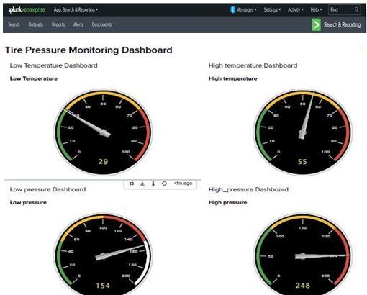

## Fig.8: Splunk Dashboard

# CONCLUSION

In this paper, a method of Real time Tire pressure monitoring system using Splunk Enterprise is proposedto monitor the temperature and pressure in vehicle tires.The Splunk Enterprise tool with the machine learning toolkit is used to index the TPMS logs and to monitor them in real time by creating visualization pivots, dashboards and reports. So it can be used to analyze the system performance, troubleshoot any failure condition and monitor the business metrics.

# REFERENCES

1. Snehal R.Javheri, Biplap Kumar and Bej Raj Singh Patel, “Wireless Tire Pressure Monitoring System for Motor Vehicles”, International Conference on Ubiquitous and Future Networks (ICUFN), pp. 744-748, June 2017
2. Adnan Shaout and Victoria Yanez, “Model Tire Pressure Sensor ID Learning Method using Fuzzy Logic”, International Conference on Information Technology (ICIT), pp. 275-279, 2017
3. Chu Kyun Bae, Sol Lim, Seung Gi Kim and Dae Jin Kim, “Tire Location Registration Algorithm using Interframe Spacing Pattern in TPMS”, International Conferences on Ubiquitous and Future Networks, pp.770-772, 2017
4. Antoniu Miclaus, Rajmond Jano and Gabriel Chidris, “Implementation of a car model for indirect pressure monitoring system”, International Spring Seminar on Electronics Technology, pp.316-321, 2016
5. Sharmila and Vibin Mammen Vinod, “Design of a Real-Time Tire Pressure Monitoring System for LMV’s”, International Conference on Green Engineering and Technologies (IC- GET), pp. 103-106, 2016
6. Rajesh Kannan Megalingam, C.Jayakrishnan, Sriraj Nambiar, Rudit Mathews, Vishnu Das and Pramesh Rao, “Automatic Pressure Maintenance system for tires in automobiles to reduce accidents”, International Conference on VLSI Systems, Architectures, Technology and applications, pp.1-6, 2016